Python project

Group members:-

1.Aditya Karmokar (rollno:-501724)

2.Aditya Patil (rollno:-501740)

3.Chris David (rollno:-501713)

4.Pratheek Hegde (rollno:-501719)

Color game using Tkinter in Python

Prerequisite : [Python GUI Tkinter](https://www.geeksforgeeks.org/python-gui-tkinter/)

[TKinter](https://www.geeksforgeeks.org/python-gui-tkinter/)is widely used for developing GUI applications. Along with applications, we can also use Tkinter GUI to develop games.

Let’s try to make a game using Tkinter. In this game player has to enter color of the word that appears on the screen and hence the score increases by one, the total time to play this game is 40 seconds. Colors used in this game are Red, Blue, Green, Pink, Black, Yellow, Orange, White, Purple and Brown. Interface will display name of different colors in different colors. Player has to identify the color and enter the correct color name to win the game.

Code:

# import the modules

import tkinter

import random

# to submit the name

def callback():

print ('You clicked the submit button! your name is:' + name.get())

def call():

print ('Your score is:' + str(score))

# list of possible colour.

colours = ['Red','Blue','Green','Pink','Black',

'Yellow','Orange','White','Purple','Brown']

score = 0

# the game time left, initially 40 seconds.

timeleft = 40

# function that will start the game.

def startGame(event):

if timeleft == 40:

# start the countdown timer.

countdown()

# run the function to

# choose the next colour.

nextColour()

# Function to choose and

# display the next colour.

def nextColour():

# use the globally declared 'score'

# and 'play' variables above.

global score

global timeleft

# if a game is currently in play

if timeleft > 0:

# make the text entry box active.

e.focus_set()

# if the colour typed is equal

# to the colour of the text

if e.get().lower() == colours[1].lower():

score += 1

# clear the text entry box.

e.delete(0, tkinter.END)

random.shuffle(colours)

# change the colour to type, by changing the

# text _and_ the colour to a random colour value

label.config(fg = str(colours[1]), text = str(colours[0]))

# update the score.

scoreLabel.config(text = "Score: " + str(score))

# Countdown timer function

def countdown():

global timeleft

# if a game is in play

if timeleft > 0:

# decrement the timer.

timeleft -= 1

# update the time left label

timeLabel.config(text = "Time left: "

+ str(timeleft))

# run the function again after 1 second.

timeLabel.after(1000, countdown)

# Driver Code

# create a GUI window

root = tkinter.Tk()

# set the title

root.title("COLORGAME")

# set the size

root.geometry("600x400")

root.configure(background='maroon')

# add an instructions label

labels = tkinter.Label(root,text="NAME:",font = ('Helvetica', 17))

name = tkinter.StringVar()

entry1 = tkinter.Entry(root,text=name)

labels.pack()

entry1.pack()

button1=tkinter.Button(root,bd=4,relief="raised",text="submit:",fg="blue",bg="white",command=callback)

button1.pack()

instructions = tkinter.Label(root,bd=4,relief="solid", text = "Type in the colour"

"of the words, and not the word text!",

font = ('Helvetica', 17))

instructions.pack()

# add a score label

scoreLabel = tkinter.Label(root,bd=4,relief="solid", text = "Press enter to start",

font = ('Helvetica', 17))

scoreLabel.pack()

# add a time left label

timeLabel = tkinter.Label(root,bd=4,relief="solid", text = "Time left: " +

str(timeleft), font = ('Helvetica', 17))

timeLabel.pack()

# add a label for displaying the colours

label = tkinter.Label(root,bd=4,relief="raised", font = ('Helvetica', 60))

label.pack()

# add a text entry box for

# typing in colours

e = tkinter.Entry(root)

# run the 'startGame' function

# when the enter key is pressed

root.bind('<Return>', startGame)

e.pack()

# set focus on the entry box

e.focus_set()

button1=tkinter.Button(root,bd=4,relief="raised",text="submit:",fg="blue",bg="white",command=call)

button1.pack()

# start the GUI

root.mainloop()

output:

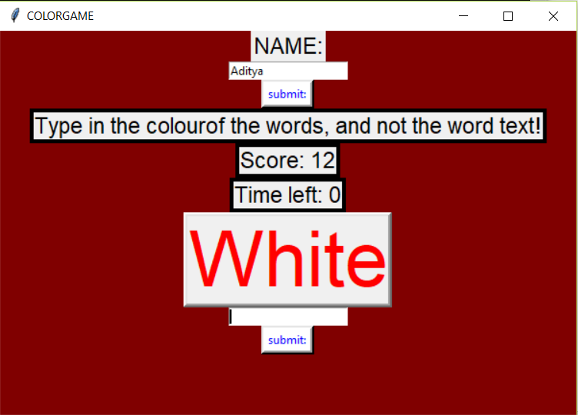

Command prompt:

